**Predicting Lifetime by Analyzing NASA Turbofan Data**

For me, aircraft engineering and airplanes are like music with perfect harmony; each component is a carefully designed masterpiece. When one component goes wrong, the impact reverberates around the world. I am talking about airplane crashes, which have a huge impact on people's lives. I remember the Jeju Air crash in South Korea, where 179 people lost their lives. What should be done to prevent such incidents from happening again?

As an electrical and electronics engineer, I have a great interest in aerodynamics and aerospace technologies, especially aircraft aerodynamics. When I see an airplane, I wonder how it can stay aloft and how the flight dynamics work. This curiosity led me to research aviation-related topics in depth. The more I studied transportation injury statistics, the more I realized the critical importance of airline safety. This realization led me to focus on aircraft components, especially engines, because they play a central role in passenger safety. My research question became clear as follows: How can I ensure the safe and efficient use of aircraft engines?

To clarify the answer to this question, I exchanged ideas with my teachers and friends who have experience in the field of data science. For example, I asked one of my teachers whether this topic would really benefit society. My teachers emphasized that the data set I chose directly affects human life, that its impact is critical, and suggested that I work in this field.

After this feedback, I started to investigate the impact of my chosen topic. Predicting the potential failures of aircraft engines could save thousands of lives by preventing accidents. In addition, lower fuel consumption would contribute to environmental sustainability by reducing carbon emissions, optimizing maintenance processes and minimizing unexpected failures. With this project, we can make a significant impact in the industry.

Therefore, this was an area of research that needed to be addressed not only technically, but also in its social, economic and environmental dimensions. It is an issue that will affect not only engineers, but also airline companies and operators, engine manufacturers, passengers.

**Methodology**  
The data set used in this study consists of sensor readings from aircraft engines that record various parameters over time. These data include measurements such as temperature, pressure and vibration levels, which provide critical information about engine performance (Saxena & Goebel, 2008). Using machine learning techniques, especially deep learning algorithms, patterns indicating engine wear will be identified by modeling dependencies over time (Zhao et al., 2019).**Strategic Outcome Targets**

**Cycle 1 (Change Application):**

**1. Model Development**

1. To develop a robust LSTM model for predicting the remaining lifetime of aircraft engines (Babu, Zhao & Li, 2016).
2. The model will be based on the LSTM algorithm that can learn the long-term dependencies of time series data.
3. It is critical to prepare the data in the correct format and complete the pre-processing stages.

**2. Planning**

1. Prepare a detailed plan to test and validate the performance of the model on the NASA Turbofan dataset (Saxena & Goebel, 2008).
2. Determine the appropriate testing and validation strategy by comparing the prediction accuracy of the model with existing methods.
3. Based on the test results, draw applicable conclusions to optimize maintenance plans.

**3. Implementation and Evaluation (From:Steve Marshall)**

1. Evaluate the predictive ability of the model by testing it on real data sets.
2. Analyze whether the model is superior to existing methods.
3. Perform hyperparameter optimization to improve model accuracy.

**2. Referencing**

- It should consider the work on predicting and preventing aircraft accidents not only as a technical achievement but also as an ethical responsibility to protect human life.

- It can guide the organization on the exemplary nature of such projects and their applicability in other sectors. Thus, the goals of protecting human life and ensuring efficiency in business processes can be achieved.

My partners in this project are experts in the defense sector (engineers, airline operators, engine manufacturers, airline companies), my professors at Amsterdam Tech, and passengers who use aircraft as a means of transportation. In order to elaborate the project, I took the opinions of experts from my partners and my Amsterdam Tech teachers. The most challenging issue in this process was to convince the experts in the defense sector, as the information I wanted to receive was confidential. using my communication skills effectively, I gathered information directly from people in the aviation industry. In this process, I asked them which sensor data was critical and what actions should be taken.

The feedback my partners gave me while leading the project was of great importance. In the first stage, I determined the important sensor data and which processes I need. In the following processes, I plan to get the opinions of the passengers. I am curious about how they have concerns about safety and I think they will contribute to the project. Then I will make an in-depth analysis of the project location with the ideas I receive. Since I made the project by taking the ideas of my partners, it will actually be a need-based project. We will be able to provide long-term benefits to the sector by contributing in critical areas such as raising safety standards and reducing environmental impacts, and the fact that the project is need-based will ensure the sustainability of that project. It will also become widespread in the sector with the references of industrial companies using the project.

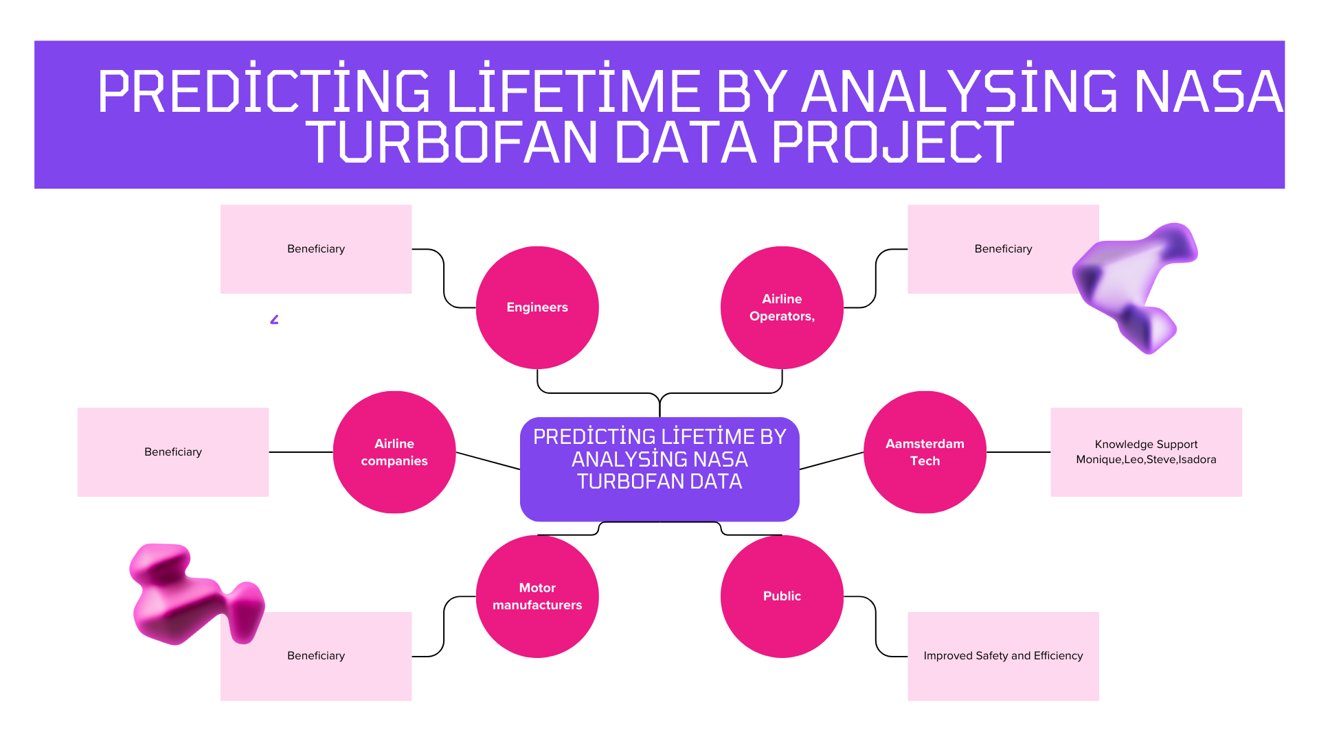

The future of aviation depends on safety measures and technological advances. Using data science and engineering expertise, we can transform aircraft maintenance into a system where the sound of an aircraft engine is not just noise; it is the heartbeat of global connectivity and human progress. With innovation and determination, we can make the skies safer in the future.

**References**

Babu, G.S., Zhao, P. & Li, X., 2016. Deep convolutional neural network based regression approach for estimation of remaining useful life. Proceedings of the International Conference on Database Systems for Advanced Applications (DASFAA), pp.214–228.

Saxena, A. & Goebel, K., 2008. Turbofan Engine Degradation Simulation Data Set. NASA Ames Research Center. Available at: <https://www.nasa.gov> [Accessed 2 February 2025].

Zhao, R., Yan, R., Chen, Z., Mao, K., Wang, P. & Gao, R.X., 2019. Deep learning and its applications to machine health monitoring. Mechanical Systems and Signal Processing, 115, pp.213–237.